**Links:** <https://github.com/TayRenYuan/Ren-Yuan_Project_PESS>

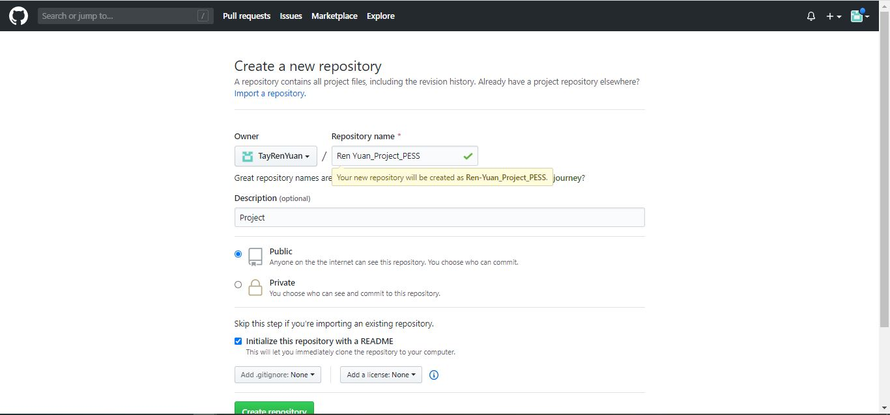**Create Repository**

**Clone or Download Button**

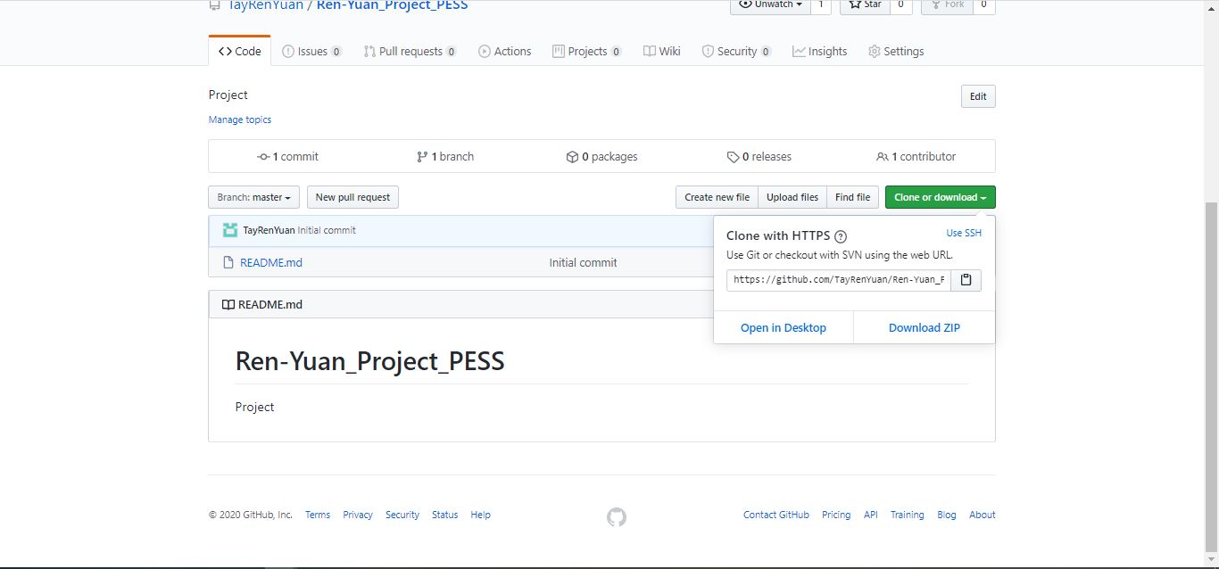

**A folder is added in the PESS**

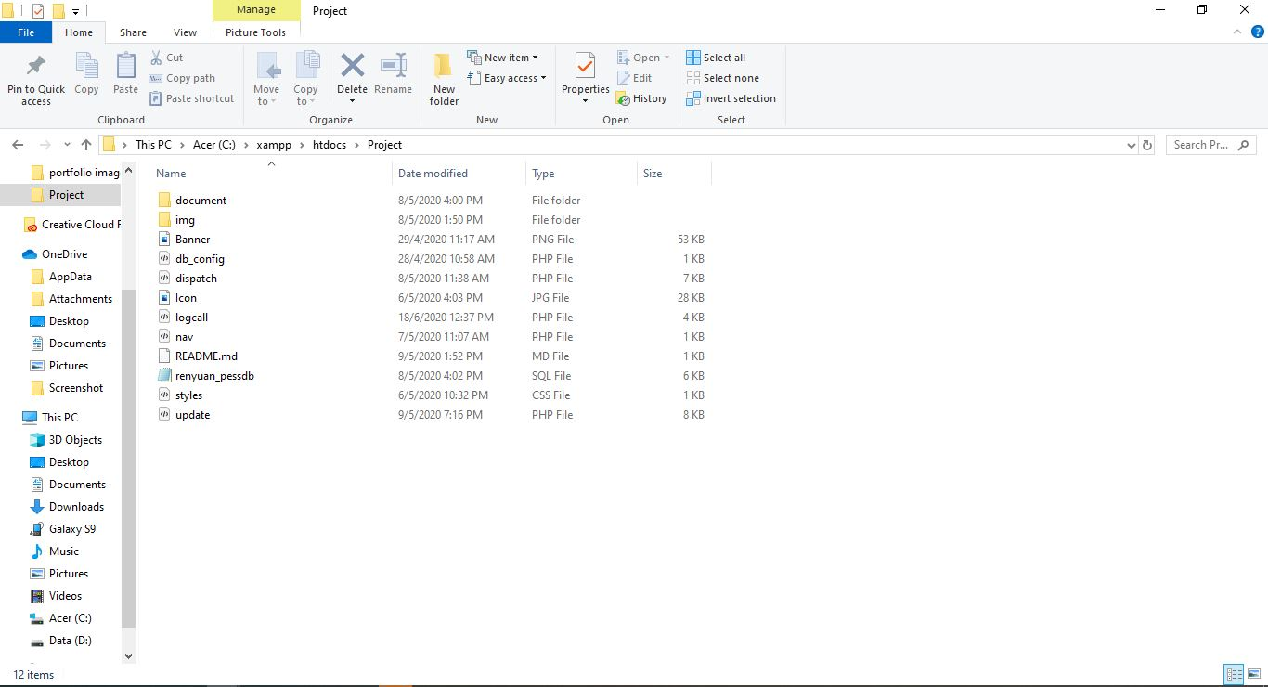

**All file is uploaded in my GitHub**

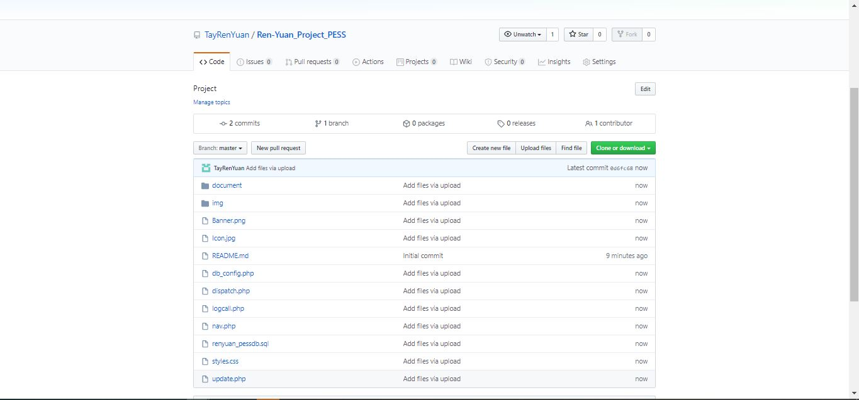

**Invite a collaborator.**

